开源软件基础大作业

基于Python的飞船大战小游戏
A simple game based on Python: Spaceship War

学 生 姓 名： 李云诺（组长）
学 号： 201892289
学 生 姓 名： 宋昊鸿（组员）
学 号： 201892437
完 成 日 期： 2021.01.08

大连理工大学
目 录
引 言 1
1 系统分析 2
2 系统设计 2
3 系统实现 3
3.1 游戏流程及截图 3
3.2 代码实现 5
结 论（设计类为设计总结） 21
成员贡献及感想 22

引 言
创建游戏是趣学语言的理想方式。看别人玩你编写的游戏让人很有满足感，而编写简单的游戏有助于明白专业级游戏是怎么编写出来的。在编写游戏的过程中，可以明白各个代码块对整个游戏所做的贡献，并尝试不同的值和设置，并对如何改进游戏的交互性有更深入的认识。
Python是一种开源的、解析性的，面向对象的语言编程。它语法优雅，可读性强，让程序员注重功能实现，而非代码本身实现细节。现广泛运用于Web开发、运维自动化、测试自动化及数据挖掘等多个行业和领域。Python语言有很大的优势：比Java、C++简单更易于使用；比PHP易懂易学并且用途更广；比Perl更简洁的语法、更简单的设计，更具可读性、更易于维护，有助于减少Bug。但它的性能不如Java、C、C++这类编译性语言强大。
本次设计使用sublime text文本编辑器编写游戏代码，build system选用Python3，Pygame是一组功能强大而有趣的模块，可用于管理图形、动画乃至声音，让你能够更轻松地开发复杂的游戏。通过使用Pygame来处理在屏幕上绘制图像等任务，可以不用考虑众多烦琐而艰难的编码工作，而是将重点放在程序的高级逻辑上。本游戏开发选用Pygame开发。

1 系统分析
在游戏《飞船大战》中，玩家控制着一艘最初出现在屏幕底部中央的飞船。玩家 可以使用箭头键左右移动飞船，还可使用空格键进行射击。游戏开始时，一群地方飞船出现在天空中，他们在屏幕中向下移动。玩家的任务是击毁敌方飞船，没击毁一架敌方飞船，增加一定分数。玩家将所有敌方飞船都消灭干净后，将出现一群新的敌方飞船，他们移动的速度更快。只要敌方飞船撞到了玩家的飞船或到达了屏幕底部，玩家就损失一艘飞船。玩家损失三艘飞船后，游戏结束。
2 系统设计
（1）根据系统分析，画出系统功能模块结构图：

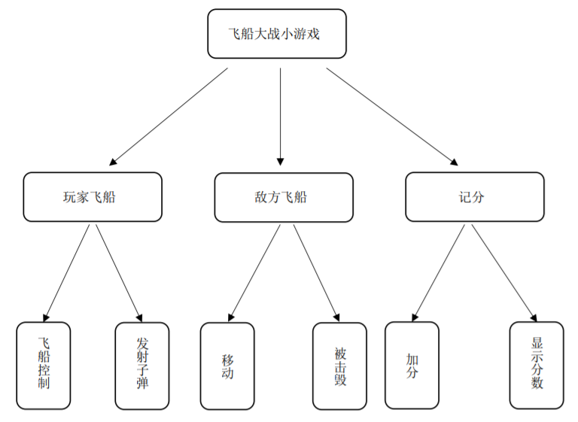
图2.1 系统功能模块结构图

（2）系统模块功能流程图：

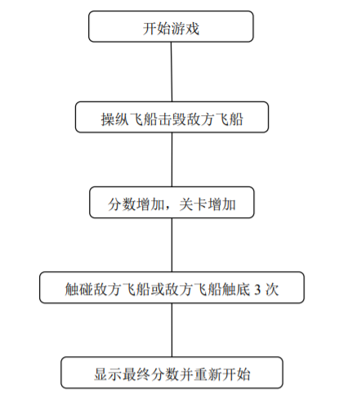
图 3.2 系统功能模块流程图

3 系统实现

3.1 游戏流程及截图
（1）运行enemy_invasion.py，显示游戏开始界面，单机play按钮开始游戏，初始有三条命，显示在左上角，界面并显示分数和关卡数，如图3.1所示。

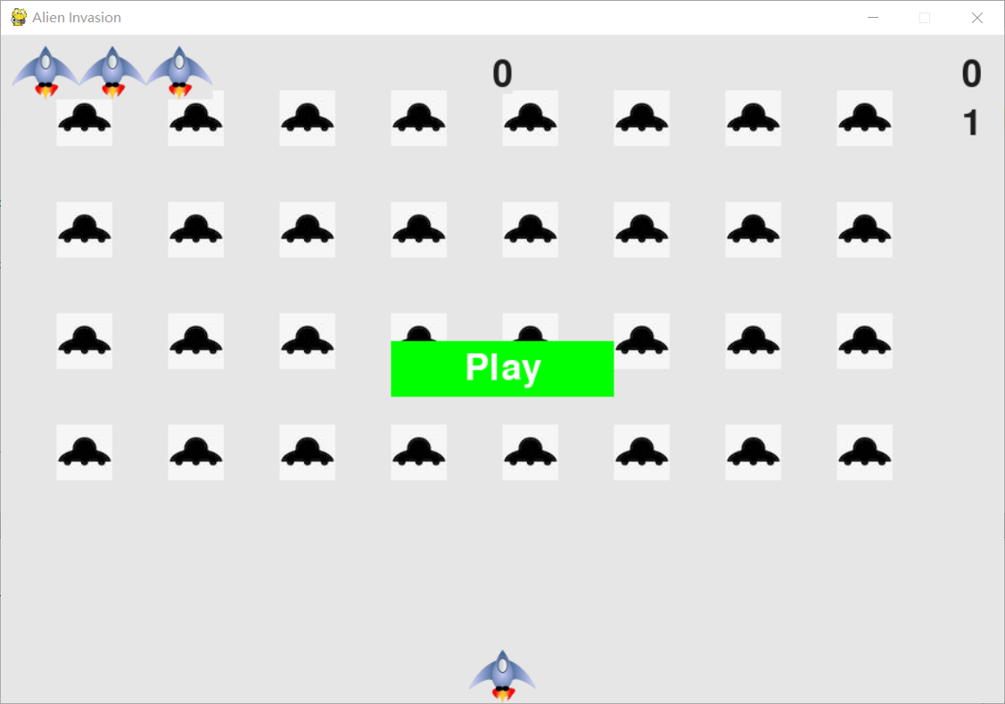
图3.1 游戏初始界面

（2）开始游戏，通过发射子弹击毁敌方飞船，获取分数，击毁全部敌方飞船则进入下一关，并且敌方飞船移动速度会变快，如图3.2所示。

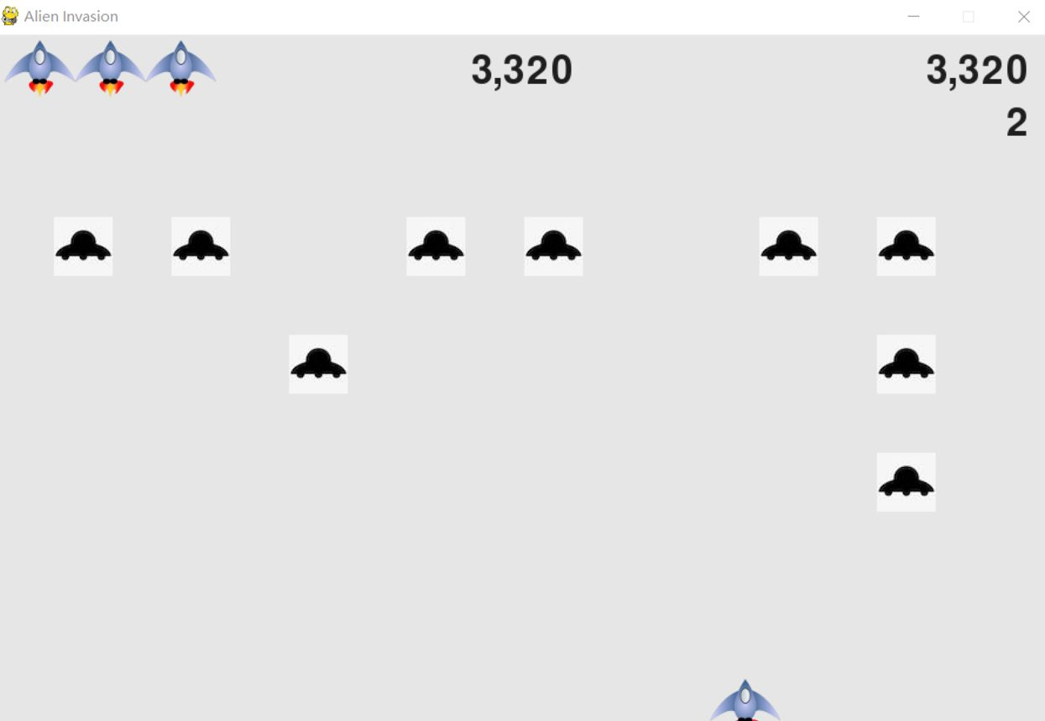
图3.2 游戏进行界面

（3）当玩家飞船触碰到敌方飞船或者敌方飞船触底，则失去一架飞船，当三架飞船均失去后，游戏失败，显示play按钮，点击以重新开始，如图3.3所示。
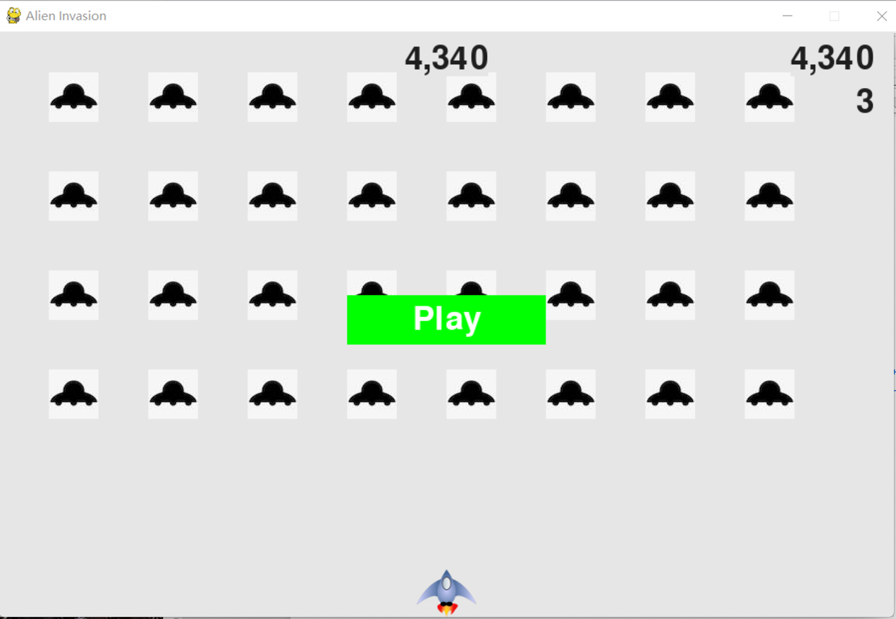
图3.2 游戏失败界面

3.2 代码实现
（1）主文件enemy_invasion.py：创建一系列整个游戏都要用到的对象，包括存储在ai_settings中的设置、存储在screen中的主显示surface以及一个飞船实例。文件enemy_invasion.py还包含游戏的主循环，这是一个调用check_events()、ship.update()和update_screen()的while循环。
import pygame
from pygame.sprite import Group

from settings import Settings
from game_stats import GameStats
from scoreboard import Scoreboard
from button import Button
from ship import Ship
import game_functions as gf

def run_game():
# Initialize pygame, settings, and screen object.
pygame.init()
ai_settings = Settings()
screen = pygame.display.set_mode(
(ai_settings.screen_width, ai_settings.screen_height))
pygame.display.set_caption("Enemy Invasion")

# Make the Play button.
play_button = Button(ai_settings, screen, "Play")

# Create an instance to store game statistics, and a scoreboard.
stats = GameStats(ai_settings)
sb = Scoreboard(ai_settings, screen, stats)

# Set the background color.
bg_color = (230, 230, 230)

# Make a ship, a group of bullets, and a group of enemys.
ship = Ship(ai_settings, screen)
bullets = Group()
enemys = Group()

# Create the fleet of enemys.
gf.create_fleet(ai_settings, screen, ship, enemys)

# Start the main loop for the game.
while True:
gf.check_events(ai_settings, screen, stats, sb, play_button, ship,
enemys, bullets)

if stats.game_active:
ship.update()
gf.update_bullets(ai_settings, screen, stats, sb, ship, enemys,
bullets)
gf.update_enemys(ai_settings, screen, stats, sb, ship, enemys,
bullets)

gf.update_screen(ai_settings, screen, stats, sb, ship, enemys,
bullets, play_button)

run_game()

（2）游戏设置文件settings.py：包含Settings类，这个类只包含方法__init__()，它初始化控制游戏外观和飞船速度的属性。
class Settings():
"""A class to store all settings for Enemy Invasion."""

def __init__(self):
"""Initialize the game's static settings."""
# Screen settings.
self.screen_width = 900
self.screen_height = 600
self.bg_color = (230, 230, 230)

# Ship settings.
self.ship_limit = 3

# Bullet settings.
self.bullet_width = 3
self.bullet_height = 15
self.bullet_color = 60, 60, 60
self.bullets_allowed = 3

# Enemy settings.
self.fleet_drop_speed = 10

# How quickly the game speeds up.
self.speedup_scale = 1.1
# How quickly the enemy point values increase.
self.score_scale = 1.5

self.initialize_dynamic_settings()

def initialize_dynamic_settings(self):
"""Initialize settings that change throughout the game."""
self.ship_speed_factor = 1.5
self.bullet_speed_factor = 3
self.enemy_speed_factor = 1

# Scoring.
self.enemy_points = 50

# fleet_direction of 1 represents right, -1 represents left.
self.fleet_direction = 1

def increase_speed(self):
"""Increase speed settings and enemy point values."""
self.ship_speed_factor *= self.speedup_scale
self.bullet_speed_factor *= self.speedup_scale
self.enemy_speed_factor *= self.speedup_scale

self.enemy_points = int(self.enemy_points * self.score_scale)

（3）游戏管理文件game_functions.py：包含一系列函数，游戏的大部分工作都是由它们完成的。函数check_events()检测相关的事件，如按键和松开，并使用辅助函数check_keydown_events()和check_keyup_events()来处理这些事件，这些函数管理飞船的移动。模块 game_functions还包含函数update_screen()，它用于在每次执行主循环时都重绘屏幕。
import sys
from time import sleep

import pygame

from bullet import Bullet
from enemy import Enemy

def check_keydown_events(event, ai_settings, screen, ship, bullets):
"""Respond to keypresses."""
if event.key == pygame.K_RIGHT:
ship.moving_right = True
elif event.key == pygame.K_LEFT:
ship.moving_left = True
elif event.key == pygame.K_SPACE:
fire_bullet(ai_settings, screen, ship, bullets)
elif event.key == pygame.K_q:
sys.exit()

def check_keyup_events(event, ship):
"""Respond to key releases."""
if event.key == pygame.K_RIGHT:
ship.moving_right = False
elif event.key == pygame.K_LEFT:
ship.moving_left = False

def check_events(ai_settings, screen, stats, sb, play_button, ship, enemys,
bullets):
"""Respond to keypresses and mouse events."""
for event in pygame.event.get():
if event.type == pygame.QUIT:
sys.exit()
elif event.type == pygame.KEYDOWN:
check_keydown_events(event, ai_settings, screen, ship, bullets)
elif event.type == pygame.KEYUP:
check_keyup_events(event, ship)
elif event.type == pygame.MOUSEBUTTONDOWN:
mouse_x, mouse_y = pygame.mouse.get_pos()
check_play_button(ai_settings, screen, stats, sb, play_button,
ship, enemys, bullets, mouse_x, mouse_y)

def check_play_button(ai_settings, screen, stats, sb, play_button, ship,
enemys, bullets, mouse_x, mouse_y):
"""Start a new game when the player clicks Play."""
button_clicked = play_button.rect.collidepoint(mouse_x, mouse_y)
if button_clicked and not stats.game_active:
# Reset the game settings.
ai_settings.initialize_dynamic_settings()

# Hide the mouse cursor.
pygame.mouse.set_visible(False)

# Reset the game statistics.
stats.reset_stats()
stats.game_active = True

# Reset the scoreboard images.
sb.prep_score()
sb.prep_high_score()
sb.prep_level()
sb.prep_ships()

# Empty the list of enemys and bullets.
enemys.empty()
bullets.empty()

# Create a new fleet and center the ship.
create_fleet(ai_settings, screen, ship, enemys)
ship.center_ship()

def fire_bullet(ai_settings, screen, ship, bullets):
"""Fire a bullet, if limit not reached yet."""
# Create a new bullet, add to bullets group.
if len(bullets) < ai_settings.bullets_allowed:
new_bullet = Bullet(ai_settings, screen, ship)
bullets.add(new_bullet)

def update_screen(ai_settings, screen, stats, sb, ship, enemys, bullets,
play_button):
"""Update images on the screen, and flip to the new screen."""
# Redraw the screen, each pass through the loop.
screen.fill(ai_settings.bg_color)

# Redraw all bullets, behind ship and enemys.
for bullet in bullets.sprites():
bullet.draw_bullet()
ship.blitme()
enemys.draw(screen)

# Draw the score information.
sb.show_score()

# Draw the play button if the game is inactive.
if not stats.game_active:
play_button.draw_button()

# Make the most recently drawn screen visible.
pygame.display.flip()

def update_bullets(ai_settings, screen, stats, sb, ship, enemys, bullets):
"""Update position of bullets, and get rid of old bullets."""
# Update bullet positions.
bullets.update()

# Get rid of bullets that have disappeared.
for bullet in bullets.copy():
if bullet.rect.bottom <= 0:
bullets.remove(bullet)

check_bullet_enemy_collisions(ai_settings, screen, stats, sb, ship,
enemys, bullets)

def check_high_score(stats, sb):
"""Check to see if there's a new high score."""
if stats.score > stats.high_score:
stats.high_score = stats.score
sb.prep_high_score()

def check_bullet_enemy_collisions(ai_settings, screen, stats, sb, ship,
enemys, bullets):
"""Respond to bullet-enemy collisions."""
# Remove any bullets and enemys that have collided.
collisions = pygame.sprite.groupcollide(bullets, enemys, True, True)

if collisions:
for enemys in collisions.values():
stats.score += ai_settings.enemy_points * len(enemys)
sb.prep_score()
check_high_score(stats, sb)

if len(enemys) == 0:
# If the entire fleet is destroyed, start a new level.
bullets.empty()
ai_settings.increase_speed()

# Increase level.
stats.level += 1
sb.prep_level()

create_fleet(ai_settings, screen, ship, enemys)

def check_fleet_edges(ai_settings, enemys):
"""Respond appropriately if any enemys have reached an edge."""
for enemy in enemys.sprites():
if enemy.check_edges():
change_fleet_direction(ai_settings, enemys)
break

def change_fleet_direction(ai_settings, enemys):
"""Drop the entire fleet, and change the fleet's direction."""
for enemy in enemys.sprites():
enemy.rect.y += ai_settings.fleet_drop_speed
ai_settings.fleet_direction *= -1

def ship_hit(ai_settings, screen, stats, sb, ship, enemys, bullets):
"""Respond to ship being hit by enemy."""
if stats.ships_left > 0:
# Decrement ships_left.
stats.ships_left -= 1

# Update scoreboard.
sb.prep_ships()

else:
stats.game_active = False
pygame.mouse.set_visible(True)

# Empty the list of enemys and bullets.
enemys.empty()
bullets.empty()

# Create a new fleet, and center the ship.
create_fleet(ai_settings, screen, ship, enemys)
ship.center_ship()

# Pause.
sleep(0.5)

def check_enemys_bottom(ai_settings, screen, stats, sb, ship, enemys,
bullets):
"""Check if any enemys have reached the bottom of the screen."""
screen_rect = screen.get_rect()
for enemy in enemys.sprites():
if enemy.rect.bottom >= screen_rect.bottom:
# Treat this the same as if the ship got hit.
ship_hit(ai_settings, screen, stats, sb, ship, enemys, bullets)
break

def update_enemys(ai_settings, screen, stats, sb, ship, enemys, bullets):
"""
Check if the fleet is at an edge,
then update the postions of all enemys in the fleet.
"""
check_fleet_edges(ai_settings, enemys)
enemys.update()

# Look for enemy-ship collisions.
if pygame.sprite.spritecollideany(ship, enemys):
ship_hit(ai_settings, screen, stats, sb, ship, enemys, bullets)

# Look for enemys hitting the bottom of the screen.
check_enemys_bottom(ai_settings, screen, stats, sb, ship, enemys, bullets)

def get_number_enemys_x(ai_settings, enemy_width):
"""Determine the number of enemys that fit in a row."""
available_space_x = ai_settings.screen_width - 2 * enemy_width
number_enemys_x = int(available_space_x / (2 * enemy_width))
return number_enemys_x

def get_number_rows(ai_settings, ship_height, enemy_height):
"""Determine the number of rows of enemys that fit on the screen."""
available_space_y = (ai_settings.screen_height -
(3 * enemy_height) - ship_height)
number_rows = int(available_space_y / (2 * enemy_height))
return number_rows

def create_enemy(ai_settings, screen, enemys, enemy_number, row_number):
"""Create an enemy, and place it in the row."""
enemy = Enemy(ai_settings, screen)
enemy_width = enemy.rect.width
enemy.x = enemy_width + 2 * enemy_width * enemy_number
enemy.rect.x = enemy.x
enemy.rect.y = enemy.rect.height + 2 * enemy.rect.height * row_number
enemys.add(enemy)

def create_fleet(ai_settings, screen, ship, enemys):
"""Create a full fleet of enemys."""
# Create an enemy, and find number of enemys in a row.
enemy = Enemy(ai_settings, screen)
number_enemys_x = get_number_enemys_x(ai_settings, enemy.rect.width)
number_rows = get_number_rows(ai_settings, ship.rect.height,
enemy.rect.height)

# Create the fleet of enemys.
for row_number in range(number_rows):
for enemy_number in range(number_enemys_x):
create_enemy(ai_settings, screen, enemys, enemy_number,
row_number)

（4）敌方飞船和玩家飞船ship.py,enemy.py。
enemy.py:
import pygame
from pygame.sprite import Sprite

class Enemy(Sprite):
"""A class to represent a single enemy in the fleet."""

def __init__(self, ai_settings, screen):
"""Initialize the enemy, and set its starting position."""
super(Enemy, self).__init__()
self.screen = screen
self.ai_settings = ai_settings

# Load the enemy image, and set its rect attribute.
self.image = pygame.image.load(r'/Users/apple/Desktop/chapter_14/images/enemy.jpg')
self.rect = self.image.get_rect()

# Start each new enemy near the top left of the screen.
self.rect.x = self.rect.width
self.rect.y = self.rect.height

# Store the enemy's exact position.
self.x = float(self.rect.x)

def check_edges(self):
"""Return True if enemy is at edge of screen."""
screen_rect = self.screen.get_rect()
if self.rect.right >= screen_rect.right:
return True
elif self.rect.left <= 0:
return True

def update(self):
"""Move the enemy right or left."""
self.x += (self.ai_settings.enemy_speed_factor *
self.ai_settings.fleet_direction)
self.rect.x = self.x

def blitme(self):
"""Draw the enemy at its current location."""
self.screen.blit(self.image, self.rect)

ship.py：
import pygame
from pygame.sprite import Sprite

class Ship(Sprite):

def __init__(self, ai_settings, screen):
"""Initialize the ship, and set its starting position."""
super(Ship, self).__init__()
self.screen = screen
self.ai_settings = ai_settings

# Load the ship image, and get its rect.
self.image = pygame.image.load(r'/Users/apple/Desktop/chapter_14/images/ship.bmp')
self.rect = self.image.get_rect()
self.screen_rect = screen.get_rect()

# Start each new ship at the bottom center of the screen.
self.rect.centerx = self.screen_rect.centerx
self.rect.bottom = self.screen_rect.bottom

# Store a decimal value for the ship's center.
self.center = float(self.rect.centerx)

# Movement flags.
self.moving_right = False
self.moving_left = False

def center_ship(self):
"""Center the ship on the screen."""
self.center = self.screen_rect.centerx

def update(self):
"""Update the ship's position, based on movement flags."""
# Update the ship's center value, not the rect.
if self.moving_right and self.rect.right < self.screen_rect.right:
self.center += self.ai_settings.ship_speed_factor
if self.moving_left and self.rect.left > 0:
self.center -= self.ai_settings.ship_speed_factor

# Update rect object from self.center.
self.rect.centerx = self.center

def blitme(self):
"""Draw the ship at its current location."""
self.screen.blit(self.image, self.rect)
（5）显示得分scoreboard.py: 这个类用于显示当前得分、最高得分、等级和余下的飞船数。
import pygame.font
from pygame.sprite import Group

from ship import Ship

class Scoreboard():
"""A class to report scoring information."""

def __init__(self, ai_settings, screen, stats):
"""Initialize scorekeeping attributes."""
self.screen = screen
self.screen_rect = screen.get_rect()
self.ai_settings = ai_settings
self.stats = stats

# Font settings for scoring information.
self.text_color = (30, 30, 30)
self.font = pygame.font.SysFont(None, 48)

# Prepare the initial score images.
self.prep_score()
self.prep_high_score()
self.prep_level()
self.prep_ships()

def prep_score(self):
"""Turn the score into a rendered image."""
rounded_score = int(round(self.stats.score, -1))
score_str = "{:,}".format(rounded_score)
self.score_image = self.font.render(score_str, True, self.text_color,
self.ai_settings.bg_color)

# Display the score at the top right of the screen.
self.score_rect = self.score_image.get_rect()
self.score_rect.right = self.screen_rect.right - 20
self.score_rect.top = 20

def prep_high_score(self):
"""Turn the high score into a rendered image."""
high_score = int(round(self.stats.high_score, -1))
high_score_str = "{:,}".format(high_score)
self.high_score_image = self.font.render(high_score_str, True,
self.text_color, self.ai_settings.bg_color)

# Center the high score at the top of the screen.
self.high_score_rect = self.high_score_image.get_rect()
self.high_score_rect.centerx = self.screen_rect.centerx
self.high_score_rect.top = self.score_rect.top

def prep_level(self):
"""Turn the level into a rendered image."""
self.level_image = self.font.render(str(self.stats.level), True,
self.text_color, self.ai_settings.bg_color)

# Position the level below the score.
self.level_rect = self.level_image.get_rect()
self.level_rect.right = self.score_rect.right
self.level_rect.top = self.score_rect.bottom + 10

def prep_ships(self):
"""Show how many ships are left."""
self.ships = Group()
for ship_number in range(self.stats.ships_left):
ship = Ship(self.ai_settings, self.screen)
ship.rect.x = 10 + ship_number * ship.rect.width
ship.rect.y = 10
self.ships.add(ship)

def show_score(self):
"""Draw score to the screen."""
self.screen.blit(self.score_image, self.score_rect)
self.screen.blit(self.high_score_image, self.high_score_rect)
self.screen.blit(self.level_image, self.level_rect)
# Draw ships.
self.ships.draw(self.screen)

结 论
本项目是在完成开源软件基础课程学习之后进行的一次设计，是对所学知识的一次深入的综合性的总复习，设计的知识面比较广泛，能把我们所学的知识都联系起来，也是一次理论联系实际的训练，能够使我们的知识掌握更牢，并能提升我们分析问题，解决问题的能力。
开源软件基础课程让我们接触并学习了Python语言，Python是一种开源的、解析性的，面向对象的语言编程。它语法优雅，可读性强，让程序员注重功能实现，而非代码本身实现细节。现广泛运用于Web开发、运维自动化、测试自动化及数据挖掘等多个行业和领域。而通过自己的设计并编写游戏是趣学编程语言的理想方式。在编写游戏的过程中，可以明白各个代码块对整个游戏所做的贡献，并尝试不同的值和设置，并对如何改进游戏的交互性有更深入的认识。因此我们很快就确定了此次项目的选题，基于Python语言编写一个简易游戏。
本次设计使用sublime text文本编辑器编写游戏代码，build system选用Python3，Pygame是一组功能强大而有趣的模块，可用于管理图形、动画乃至声音，让你能够更轻松地开发复杂的游戏。通过使用Pygame来处理在屏幕上绘制图像等任务，可以不用考虑众多烦琐而艰难的编码工作，而是将重点放在程序的高级逻辑上。
项目设计是对我们学习的补充和扩展，实现自我完善和独立工作的过程，是大学学习的特色和优势。而这一切的得来都是努力的结果，以后我们要继续发扬这种精神，将所学的知识融入到今后的生活和工作中。

成员贡献及感想
（1） 201892427 李云诺（组长）
工作占比：50%
主要工作内容：主要代码实现（game_stats.py, game_functions.py, bullet.py, scoreboard.py，alien.py），代码运行及调试。
感想：我在这门课程中第一次学习用python这门语言进行项目编程，在刚开始学习的阶段，老师每堂课都带领我们一起练习，边学边熟悉这门语言的功能和特点，我对python有了初步的熟悉。项目的完成过程困难重重，挑战多多，也一度停滞不前，十分感谢我的队友以及其他帮我解决困难的朋友，让我们成功完成飞船大战这个小项目。经过这段时间的学习，我感受到了开源的魅力。同时通过这一项目的锻炼，我对python有了更深层次的理解和掌握，将理论知识应用到实践中去，不断练习才能不断提升自己的本领。最后感谢老师和助教这学期的辛苦付出！
（2） 201892075 宋昊鸿（组员）
工作占比：50%
主要工作内容：主要代码实现（enemy_invasion.py, button.py, enemy.py, ship.py, settings.py），文档的撰写与编辑。
感想：在项目制作期间，出现了各种各样的问题，项目代码也出现了很多错误，但是，虽然在这个过程中遇到了许多挫折，甚至最终也没有做出完美预期的成果，但是这也让我对Python这门编程语言有了更深的了解。并且，在最终完成后，我也体验到了极大的成就感和喜悦感。可以说，经过这段时间的课程学习和大作业的完成，我对Python有了更多的了解，从一个小白成为了一个入门者。经过这次开发，我也懂得了理论知识和实践的区别所在，在以后的学习过程中，无论学习什么，一定要多实践，实践了才能发现更多的错误，才会对知识有更深入的理解和运用。

